Lesson 16 – Maps

What is a map?
Basic Operations with maps
For Each command
What students should know
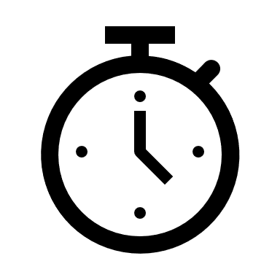2h

A map is a collection that contains pairs of keys and values. For example, records in a phone book or a dictionary can be a map. Other times it is also referred to by the name dictionary.
Figure 1 Yellow Pages Map
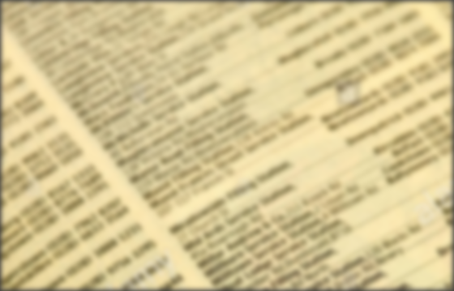
Each key is unique so you can refer to it uniquely. This means that if you add a key/value pair (entry) and the collection already contains an entry with the same key, the previous entry will be removed from the map.
The value can be any type from a simple variable to an object.

Create a map
A map is declared in B4X as below:
Private EnglishGreek As Map
EnglishGreek.Initialize

Private EnglishItalian As Map
EnglishItalian.Initialize

Where EnglishGreek the name of the first map was created and EnglishItalian the second. In addition, a map to be used must be initialized.

Insert items into Map
Put method allow to add keys/values to a map. For example the two maps bellow use the put method.

The Put method is stated as follows:
<map name>.put(key, value)
The following example creates two Maps with key words from The English language and values in Greek and Italian.
Private EgnlishGreek As Map
EgnlishGreek. Initialize

Private EnglishItalian As Map
EnglishItalian. Initialize

EgnlishGreek. Put("Memory","Memory")
EgnlishGreek. Put("Screen", "Screen ")
EgnlishGreek. Put("Printer ","Printer")
EgnlishGreek. Put("Programming Language", "ProgrammingLanguage"))

EnglishItalian. Put(“Memory”, "Memoria")
EnglishItalian. Put(“Screen”, "Schermo")
EnglishItalian. Put(“Printer”, "Stampante")
EnglishItalian. Put(“Programming Language”, "Linguaggio di Programmazione")

Use a map value
To use a value from a map, you only need to use the Get command.
<map name>. Get(Key As Object)
GRWord = EnglishGreek.Get("Screen")
Log(GRWord) ' Shows Screen

ITWord = EnglishItalian.Get("Screen")
Log(ITWord) ‘Shows Schermo

Returns Value with Key “Screen” in Variable GRWord From map EnglishGreek, and the Value which Corresponds In Key “Screen” From map EnglishItalian In Variable ITWord.
Remember
The type of variable that the value accepts from the map must be the same type As the value. Key types must always be string or number.

If the key does not exist on the map, then Null is returned
ITWord = EnglishItalian.Get("Keyboard")
Log(ITWord) ‘Shows null

Indexes in Maps
You can use indexes as in lists to access either the key or key value.
<map name>. GetKeyAt(Index As Int)
Key = EnglishItalian. GetKeyAt(2)
Log(key) ‘ Shows Printer

<map name>. GetValueAt(Index As Int)
Value = EnglishItalian.GetValueAt(2)
Log(Value) ‘ Shows Stampante

Also, the GetKeyAt and GetValueAt commands can be used in a iterative process to get all map values:
For i = 0 To EnglishGreek.Size - 1
Log(EnglishGreek.GetValueAt(i))
Next

The above iteration shows the values of map EnglishGreek.

The command “for each”
One iteration command that has not been discussed so far is the command for each. This command creates an iteration that accepts items from a list of values such as a map for example.

For Each word As String In EnglishItalian.Values
Log(word)
Next
The above iteration defines a variable which (the word in the example) will accept each time the value of the current position. You do not need a counter or step like for loop. Next steps give next map values and stops when map keys end.

For Each key As String In EnglishItalian.Keys
Log(key)
Next
Displays the keys stored in the map.

To get both keys and values at the same time you can use the command for each as below:
For Each key As String In EnglishItalian.Keys
Log(key & EnglishItalian.GetValueAt(key))
Next

Check key existence
If you are looking for a key, you can scan the table to find out if it exists or not, but it's easier and faster to use the ContainsKey command
<map name>. ContainsKey(Key As Object)
If EnglishGreek.ContainsKey("Keyboard") Then
Log("There is already an entry with this key !", "")
Else
Log("There is not such a key!", "")
End If

Delete Key and Empty Map
The Remove command deletes a key (and of course its value from a Map)
<map name>. Remove(Key As Object)
EnglishGreek. Remove("Memory")
Deleting all items from a Map is done with the Clear command.
EnglishGreek. Clear

Exercises

- Create a map with Country names as keys and their capitals as values.
CUBA HAVANA
CYPRUS NICOSIA
CZECHIA PRAGUE
EGYPT CAIRO
KENYA NAIROBI
MEXICO MEXICO CITY
PERU LIMA
VIETNAM HANOI
PORTUGAL LISBON

Source: https://www.boldtuesday.com/pages/alphabetical-list-of-all-countries-and-capitals-shown-on-list-of-countries-poster

- Add 3 countries with their capitals.
- Display the names of countries and their capitals by using the for each command
- Create a new map that contains the names of the capitals as keys and values country’s names.
- In an appropriate text field, enter the name of a city and then display the country that owns the city.

